Computer Graphic Assignment 1

Xiang Zhang CS560

The line drawing function is the basic function provided by many graphics tools, such as the MS Word, power point, etc. Brute-force method is too slow and may lead to many errors. Bresenham algorithm is an efficient method to draw a line. Furthermore, calculating the distance of each line pixel’s related neighbors and to decide the intensity of the neighbors can help us to implement the anti-aliased effect. Gupta-Sproull algorithm is known for achieving such function.

1. The first part of codes are in wake.c, in which I implement the Bresenham mid-point algorithm to draw a line. Using Gupta-Sproull algorithm to implement antialiasing. The method is :

void midpointBresenham(Point p1,Point p2)

Using ‘d’ to decide whether go North East or East, and set intensity of pixels by calculating the distance of a pixel to the line. two_vdx is the variable I used to calculate such distance. Implement all cases in 8 half- quadrant by swaping x to -x, y to -y, x to y and x to -y.

void drawLine(Point p1,Point p2)

in this method is where I draw an line by OpenGL’s drawing line method.

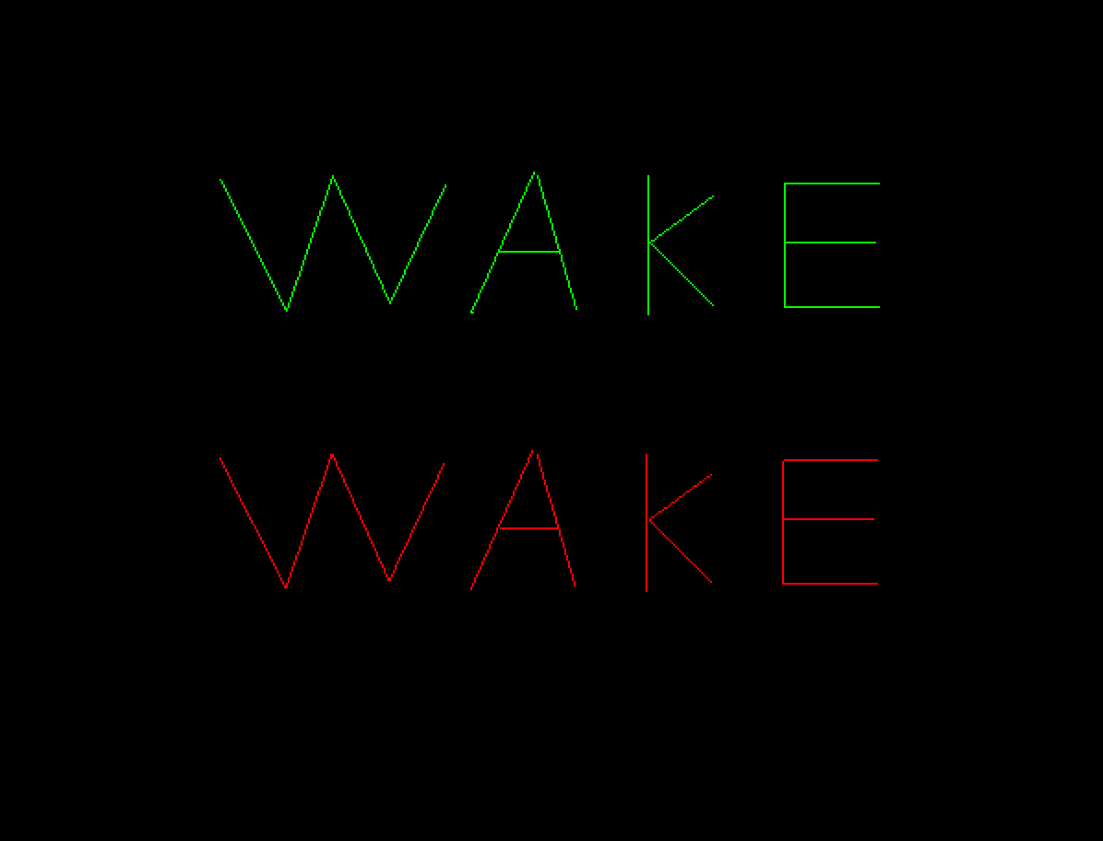

The green line is creaed by mid-pointBresenham algorithm and the orther is by the OpenGL method.

1. In the file of coordinate.c is where I draw the coordinate. There is no other difference of wake.c except there isn’t OpenGL drawing line method.

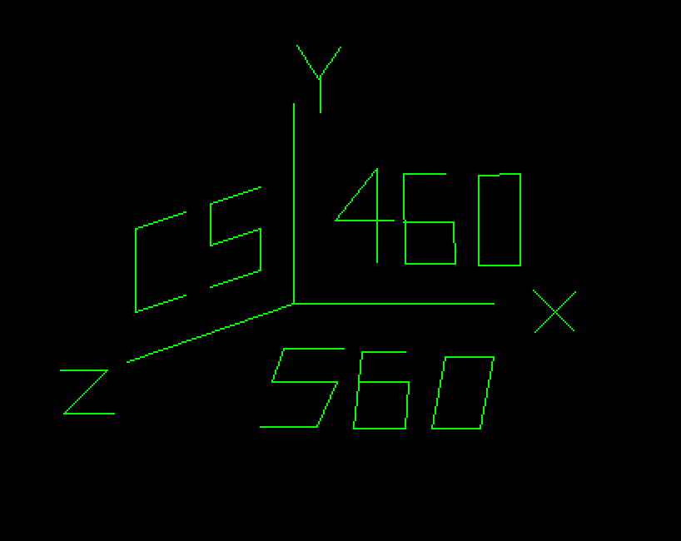

The last part of codes are in shape.c , where I implement the circle , eclipse and curve.

void bresenhamCircle(int cx, int cy, int r)

Circle is an central symmetry and axis symmetry shape. So we can only draw 1/8 circle and change the x and y to complete the other parts. It is similar to line , when d < = 0 , go East and set d += 2x + 3, else go EastSourth and set d += 2(x-y)+5.

void bresenhamEclipse (int a, int b, int xLoc, int yLoc)

is the method of eclipse algorithm. The params of a and b represent the long and short axis of an eclipse. To be specific, it will draw an circle when a is equal to b.

Meanwhile, I use the eclipse method to implement the curve method, by control the changing mechanism of x and y.

void setEclipsePixel(int x, int y) is where I implement it. There is an menu to decide which shape to draw! Click right mouse button to show the menu.

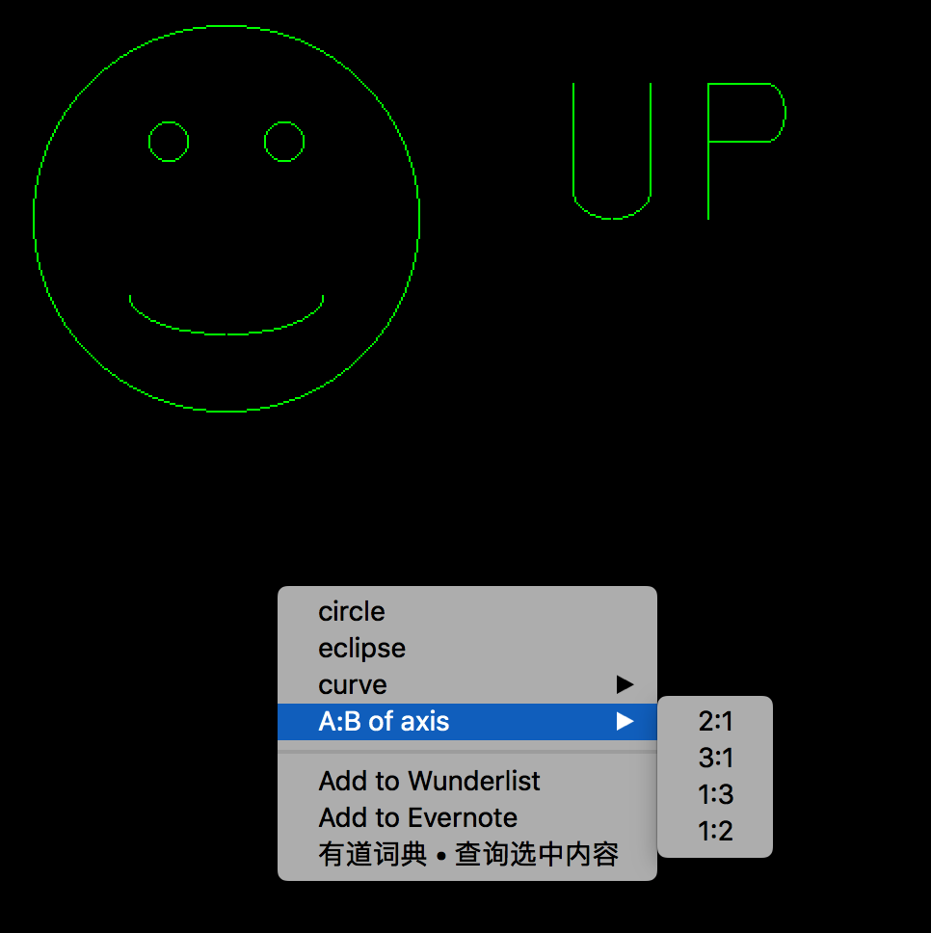

A:B decided the ratio of long axis vs short axis, which could infect both eclipse and curve!

To run the code: g++  *.c -o  name  -framework OpenGL -framework GLUT